**WEEK-1[Design Patterns and Principles]**

**Exercise 1: Implementing the Singleton Pattern**

**Scenario:**

You need to ensure that a logging utility class in your application has only one instance throughout the application lifecycle to ensure consistent logging.

**Code:**

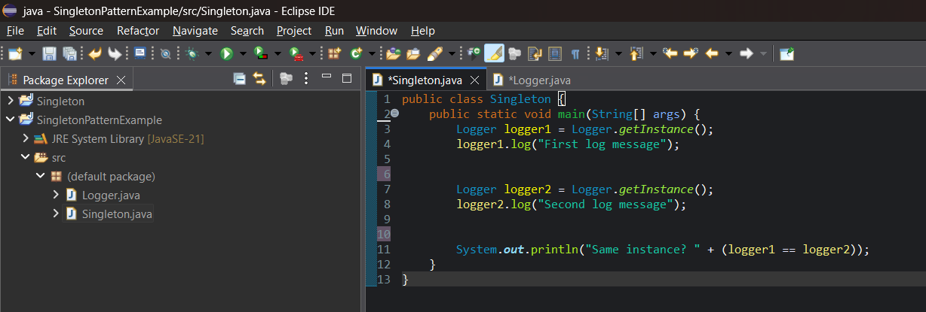

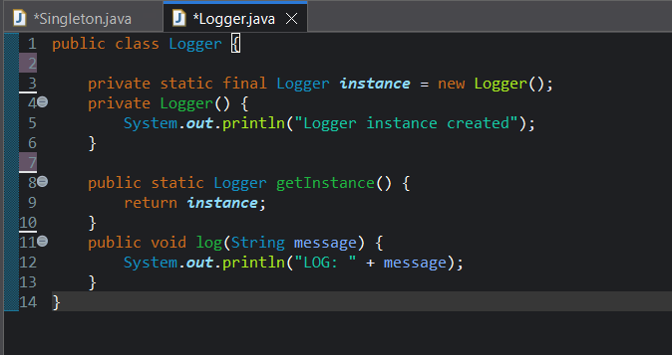

**OUTPUT:**

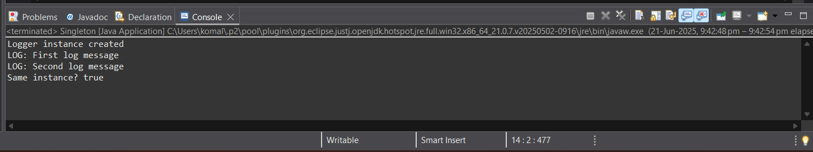

**Exercise 2: Implementing the Factory Method Pattern**

**Scenario:**

You are developing a document management system that needs to create different types of documents (e.g., Word, PDF, Excel). Use the Factory Method Pattern to achieve this.

**CODE:**

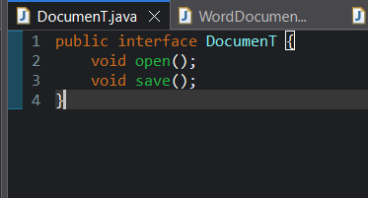

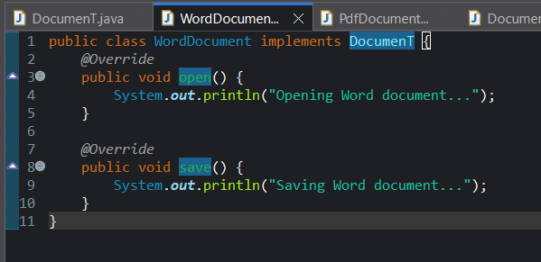

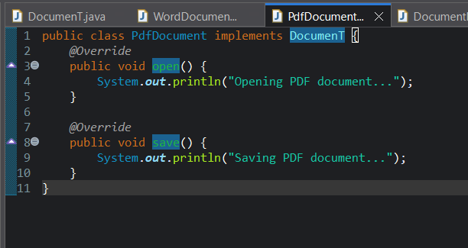

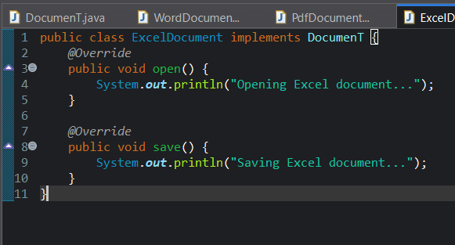

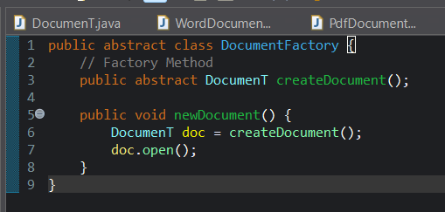

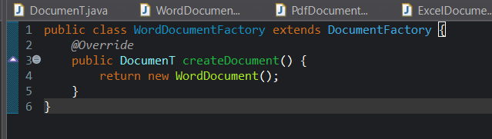

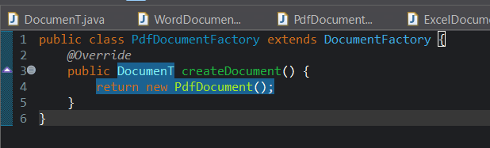

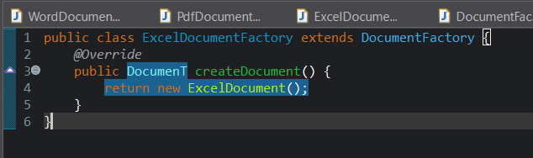

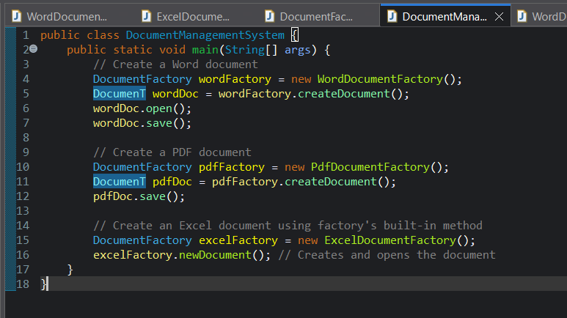

**OUTPUT:**

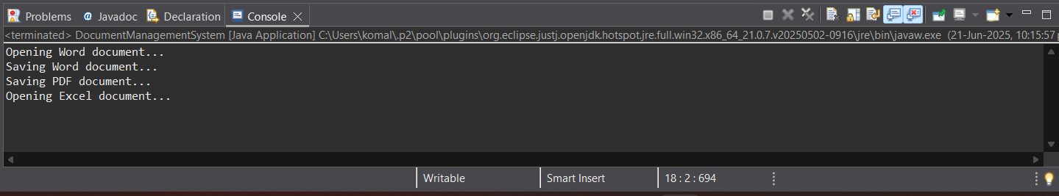

**Exercise 2: E-commerce Platform Search Function**

**Scenario:**

You are working on the search functionality of an e-commerce platform. The search needs to be optimized for fast performance.

**CODE:**

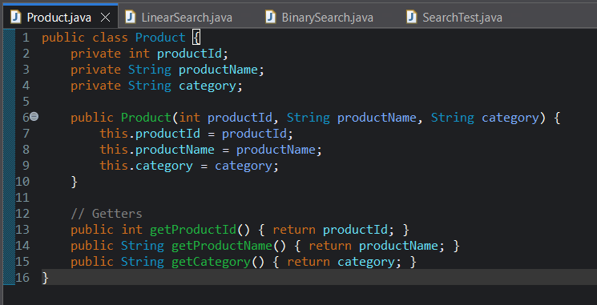

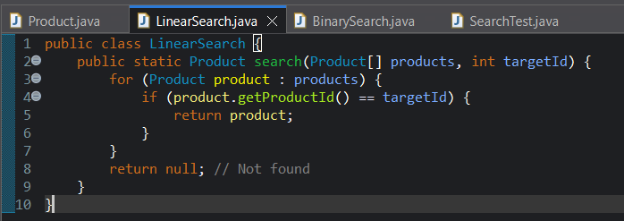

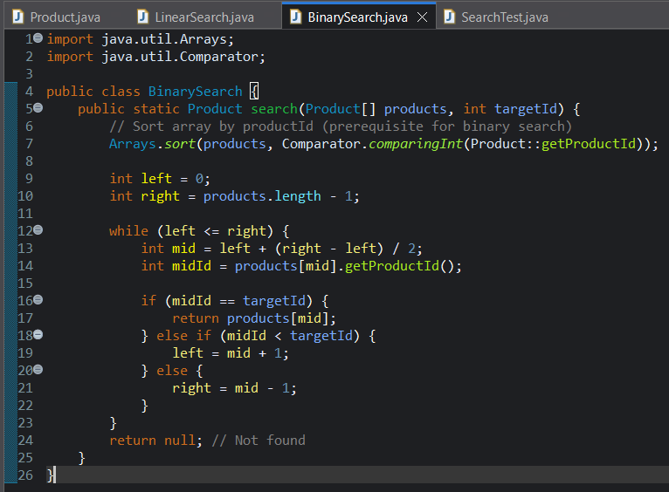

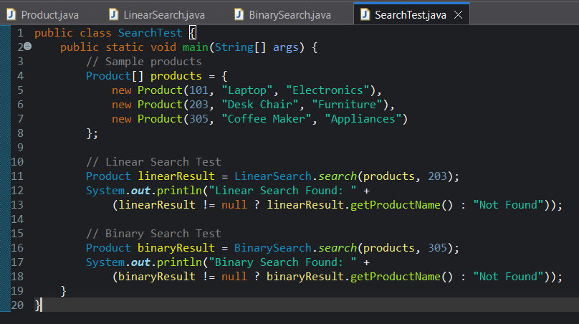

**OUTPUT:**

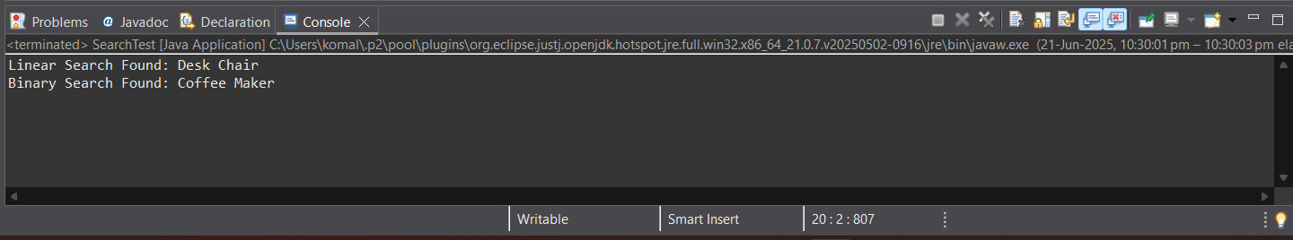

**Exercise 7: Financial Forecasting**

**Scenario:**

You are developing a financial forecasting tool that predicts future values based on past data.

**CODE:**

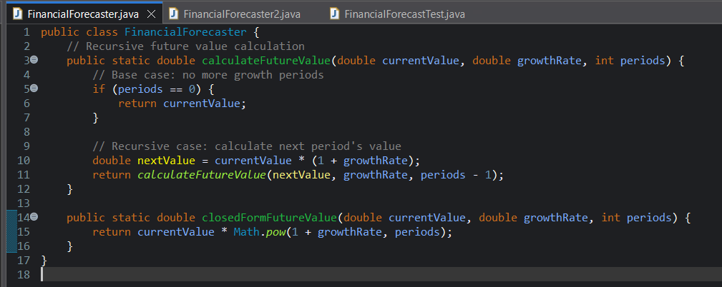

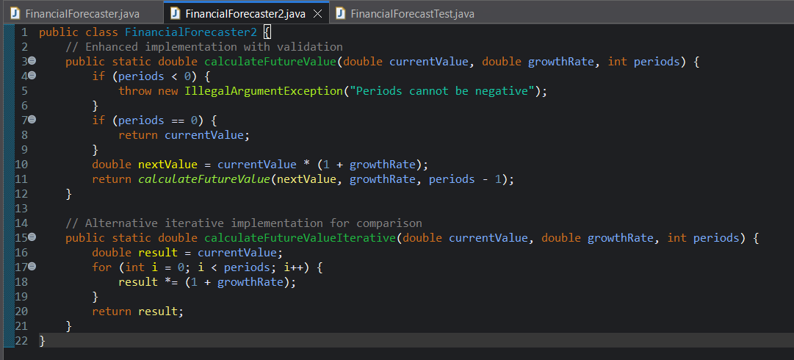

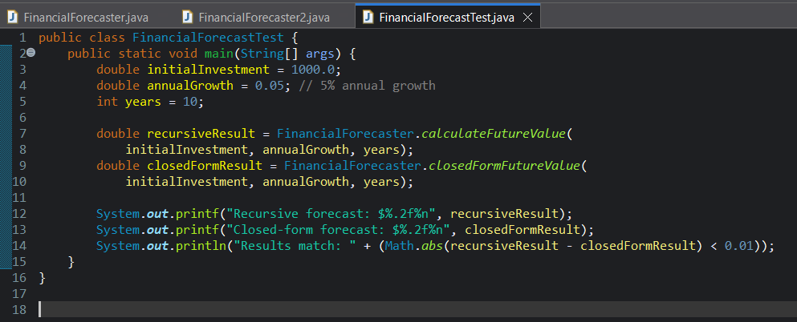

**Output:**

